**Lab Assignment No: 09**

**NAME:** TAKANKHAR SHUBHAM

**ROLLNO:** 54

**SUBJECT CODE**: IT8002

**SUBJECT NAME**: CPP AND JAVA

**GR NO:** 119C0054

**BATCH:** B3

.Write Program for following using c++ Exception handling:

•Divide by zero

•Array index out of bounds exception

#include<iostream>

//EXCEPTION HANDLINF

using namespace std;

int main()

{

    //DivideByZero

    int x,y;

    cout<<"Enter First No to divide:";

    cin>>x;

    cout<<"Enter First No to divide:";

    cin>>x;

    try

    {

        if (x==0 || y==0){

        throw "Division by zero Error!";

        }

        else{

        cout<<"Division is:"<<y/x<<endl;

        }

    }

    catch(char const*e)

    {

        cout<<e<<endl;

    }

    //ArrayOutOfBound

    int arrays[]={1,2,3,4,5};

    cout<<"Array:1,2,3,4,5"<<endl;

    cout<<"Enter Element to Access from Array:";

    int i;

    cin>>i;

    try{

        if(i<0 || i>4){

            throw "Array Index Out Of Bound";

        }

        else{

            for(int i:arrays){

                cout<<i<<" ";

            }

            cout<<endl;

        }

    }

    catch(char const*f){

        cout<<f<<endl;

    }

    //hold screen

    cin>>y;

}

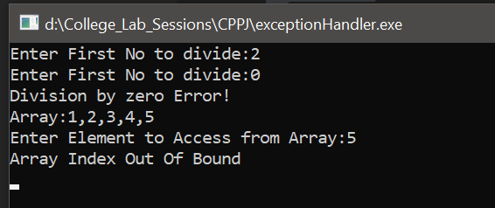

2. Write Program for Stack underflow(stack empty) using c++ Exception handling:

#include<iostream>

#define size 5

using namespace std;

  class stack

{

     int data[size];

     int top;

public:

     stack()

     {

          top=-1;

     }

     void push();

     void pop();

     void display();

};

void stack::push()

{try{

     if(top==size-1)

     {

          throw top;

          return;

     }

     else

     {

          top++;

          cout<<"Enter Data : ";

          cin>>data[top];

     }}

     catch(...){

          cout<<"Stack Overflow";

     }

}

void stack::pop()

{   try{

     if(top==-1)

          throw top;

     else

     {

          cout<<data[top]<<"deleted "<<endl;

          top--;

     }

}

catch(int i){

    cout<<"Stack Underflow";

}

}

void stack::display()

{

     int t=top;

     while(t>=0)

     {

          cout<<data[t]<<endl;

          t--;

     }

}

int main()

{

     stack st;

     int ch;

     do

     {

          cout<<"\n1. Push\n2. Pop\n3. Display \n4.Quit\nEnter Choice(1-4) ";

          cin>>ch;

          switch(ch)

          {

               case 1: st.push();break;

               case 2: st.pop();break;

               case 3: st.display();

          }

     }while(ch!=4);

}

